CONVENTIONAL WELD

TUBE TO BODY WELD
INCREASED BEAM INTENSITY NEXT TO BODY - ONE PASS

DIAPHRAGM WELD
WITH OR WITHOUT EXTERNAL RING
ELECTRON BEAM WELD

WELDS THAT ARE NORMALLY INACCESSIBLE

TUBE-TO-TUBE WELD DEPTH OF WELD
CAN BE LESS THAN 100%

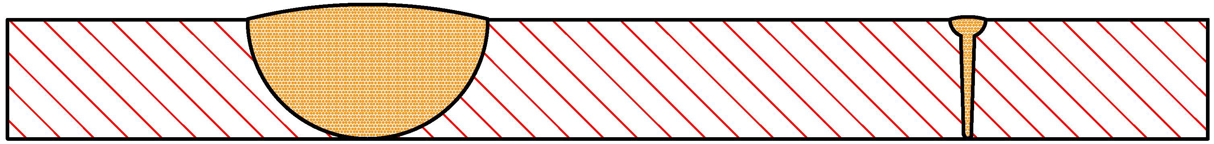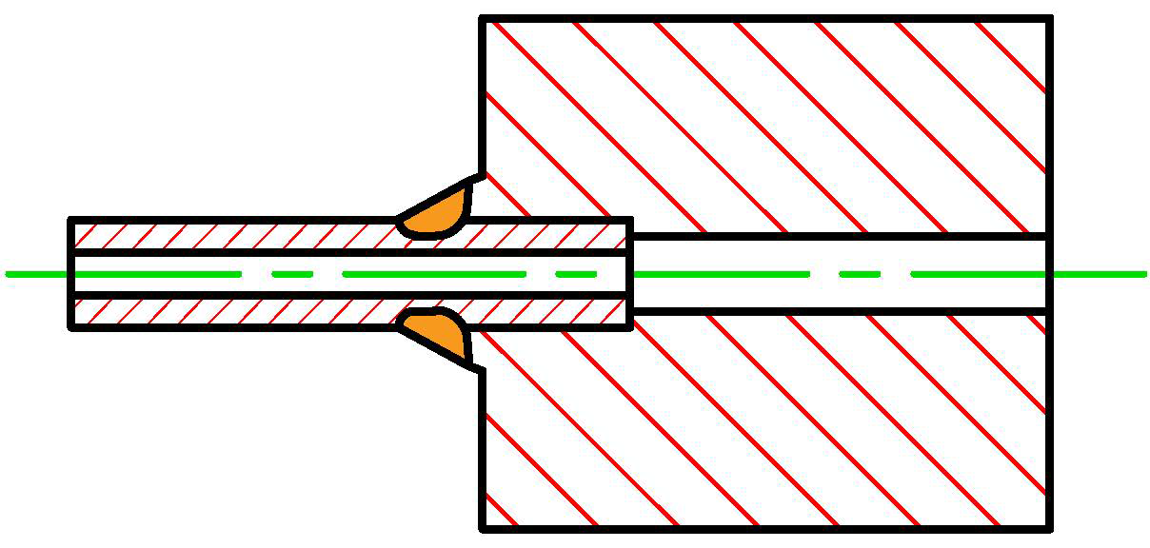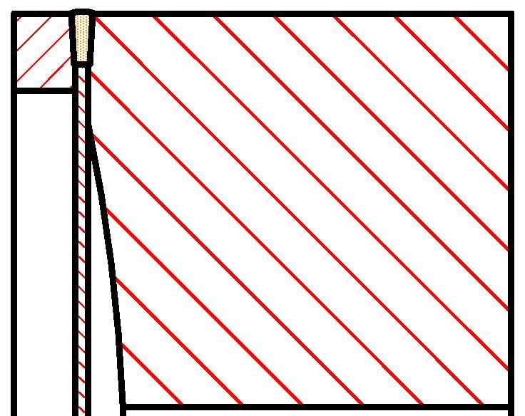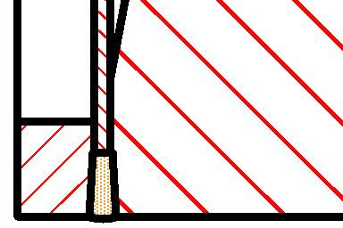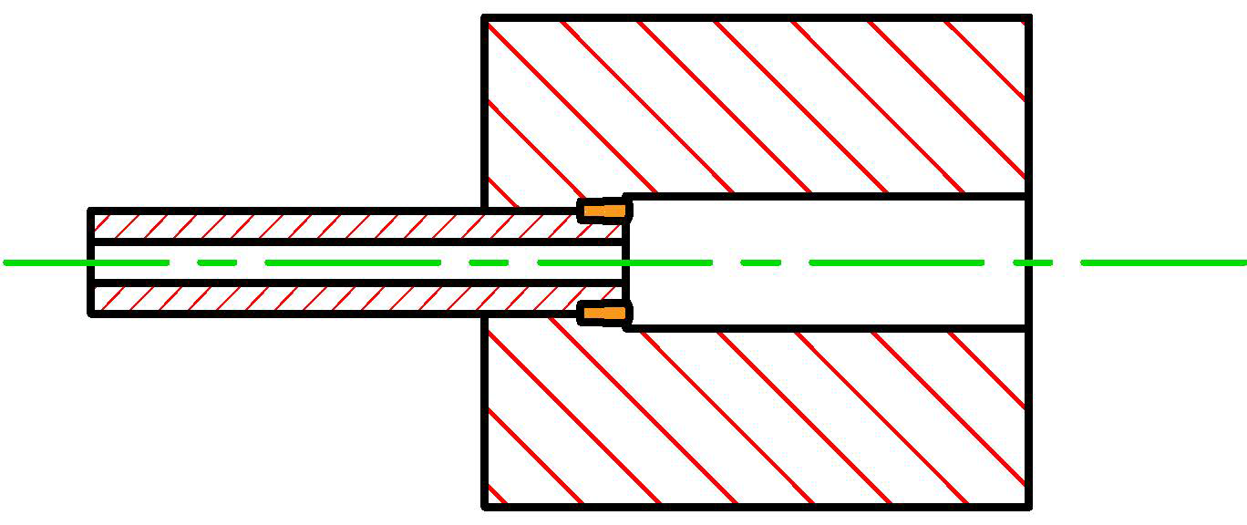

EXAMPLES OF ELECTRON BEAM WELDS

